Definition:

- Iterative optmisation.
- first order.
- local minimum.
- Differentiable function.
- Move against the oppoisite direction of the gradient.

Minimum/optmised values directly
we can get the minimum value of the parameters with the help of the closed form the equation.

Reason: matrix inverse constly conputation.
But this will not work if the value, or the dimenssion of the matrix is too large, in such a way wwe will not be able to get the inverse of the function.

SLOPE:
- Differentiation of loss function.
- You will be having a equation on which you need to take the differentiation and then equate that to zero.
- 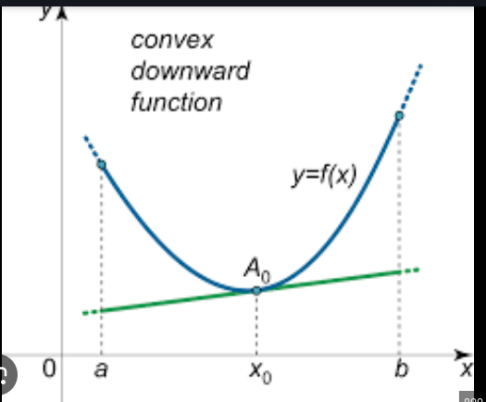
  - The point at x=x0, is the point where we will be having the slope = 0, which is the minimum.
  - Slope is nothing but dy/dx. y is nothing but the equation of y, this is represening the second order, x^2.
  - Anything other than this point the slope is not equal to zero. THis is what we wanted to find, which

- s

